**Project and Developer Details:**

|  |  |
| --- | --- |
| **Project Name:** | Learner’s Academy Backend Portal |
| **Developer:** | Vema Venkatesh Gangodi |
| **E-Mail:** | [venkatesh.gv484@gmail.com](mailto:venkatesh.gv484@gmail.com) |

**Core concepts used in the project:**

* Servlets
* Filters
* JSPs
* Database Operations
* Hibernate Framework
* Basic HTML and CSS
* Maven

**GitHub repository Link:**

<https://github.com/venkateshgv484/PGP-FSWD-PROJECT-2>

**Unique Selling Points:**

* **Login option**
  + User cannot access the application without login
* **Academy Subjects:**
  + User can add/maintain/delete the subjects
* **Academy Teachers:**
  + User can add/maintain/delete the teachers
* **Academy Classes:**
  + User can add/maintain/delete the classes
  + There is an option to assign subject & teachers to the class
* **Academy Students:**
  + User can add/maintain/delete the students
  + Only one class is allowed to a student

**Output:**

**Login Page**

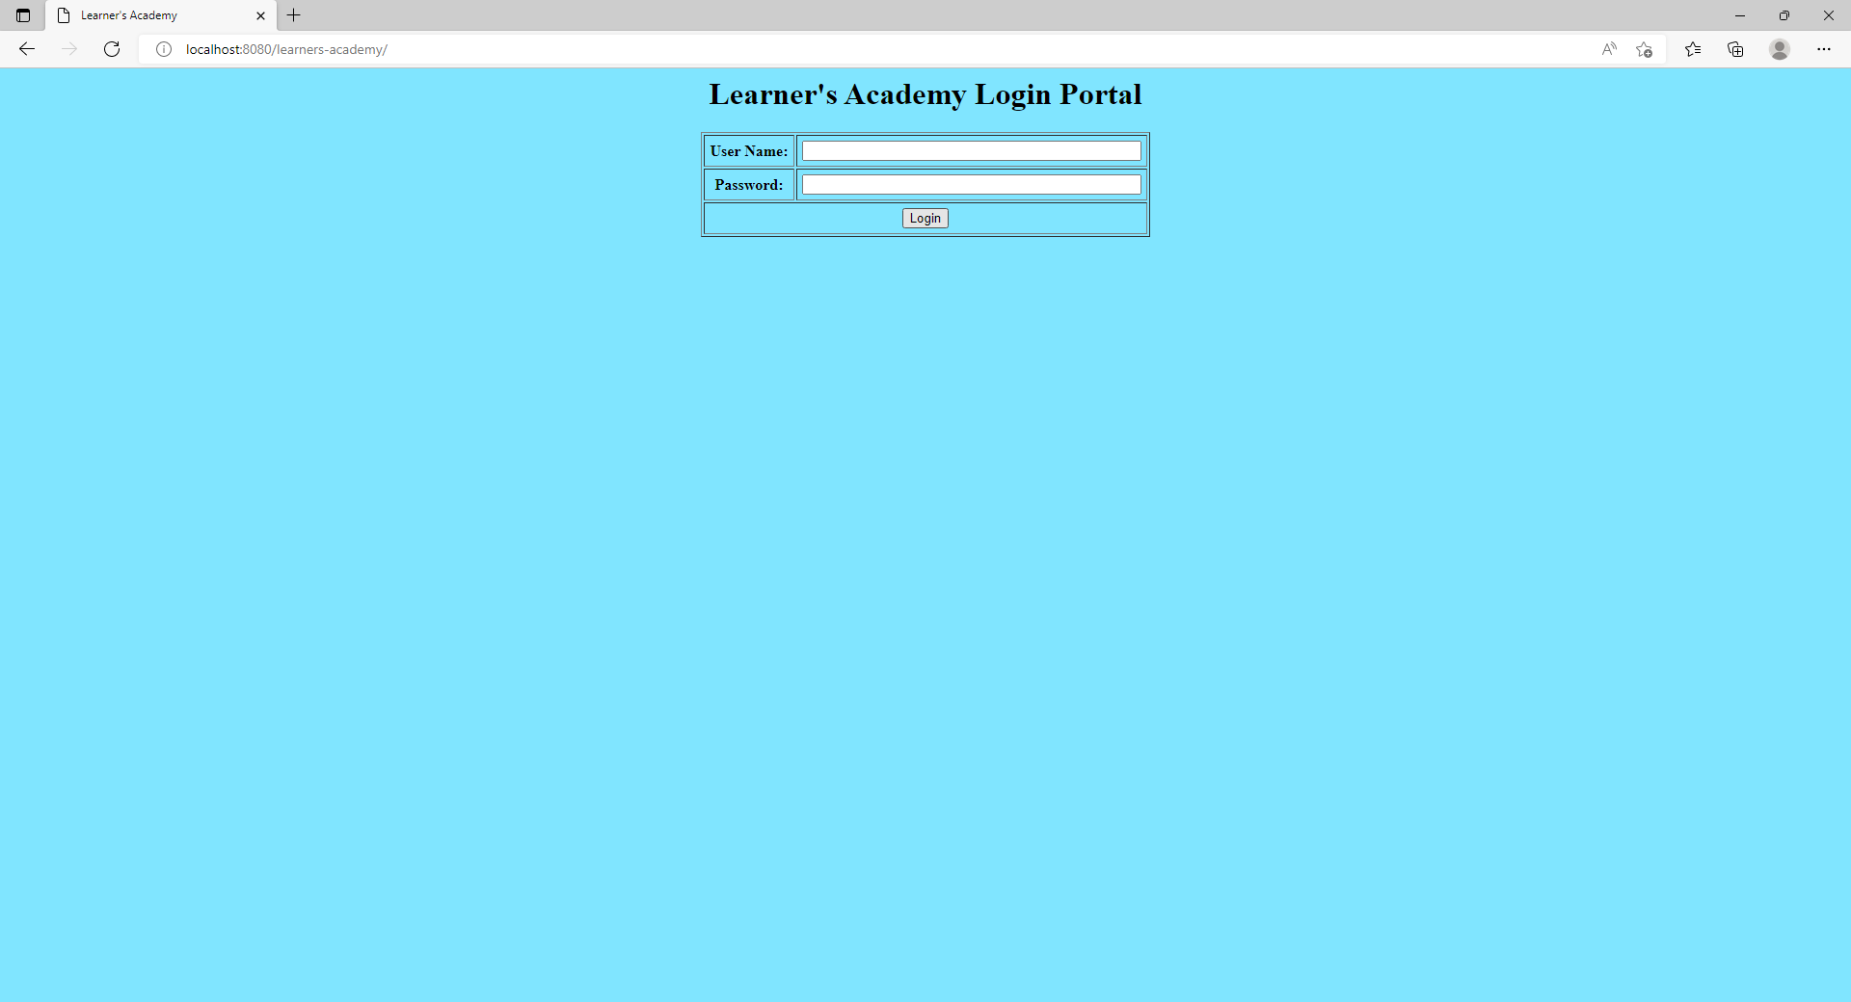

**Home Page**

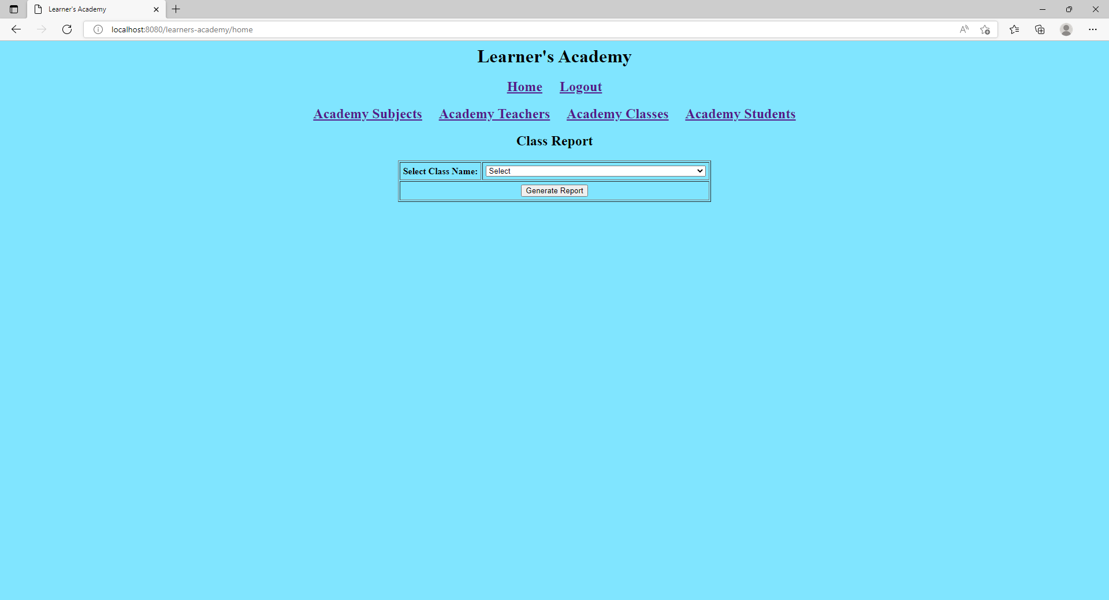

**Subjects Maintenance Page**

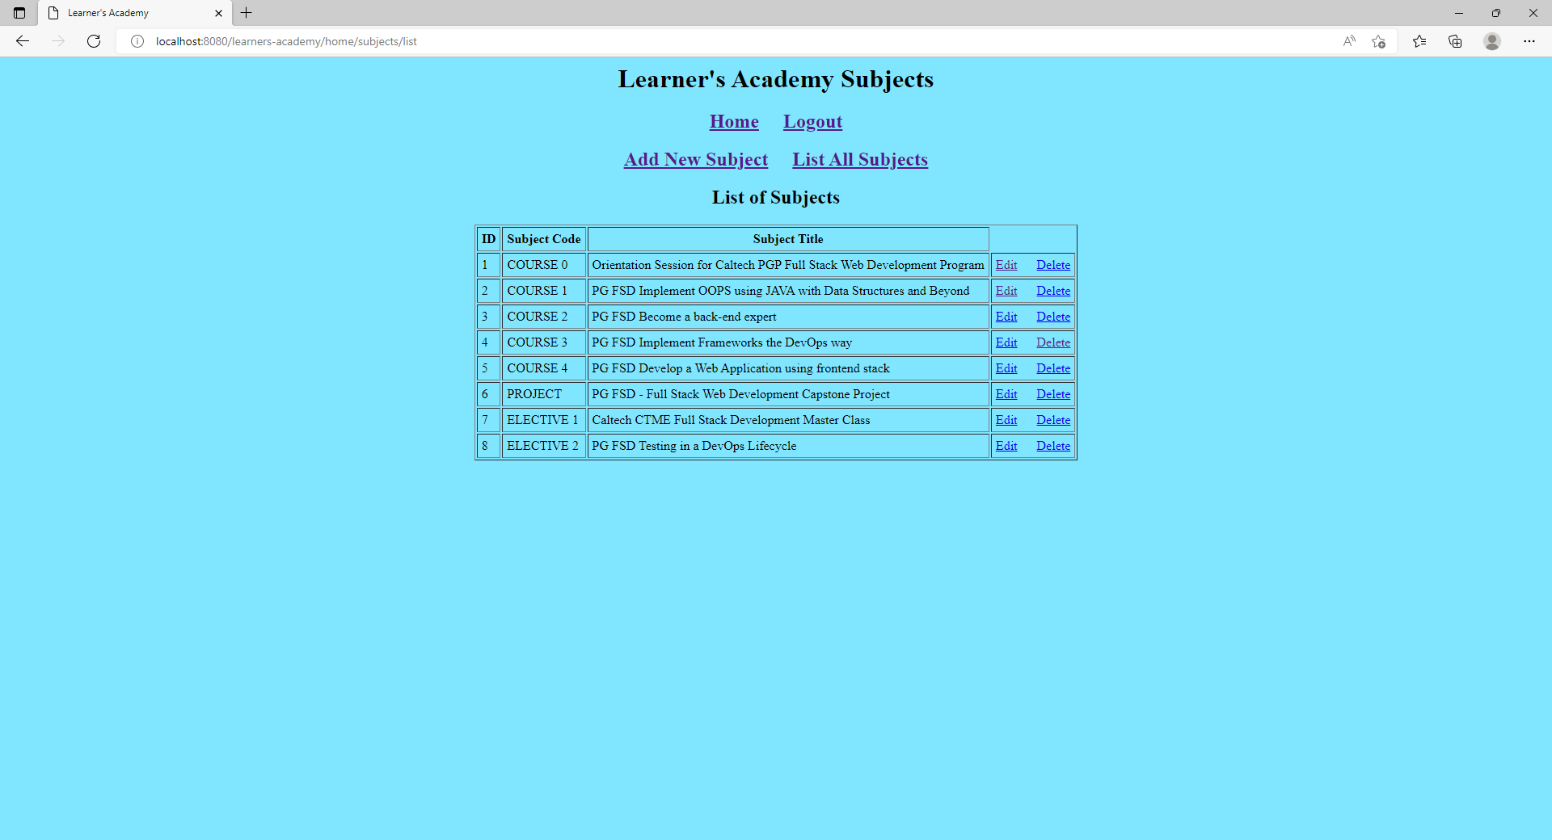

**Teachers Maintenance Page**

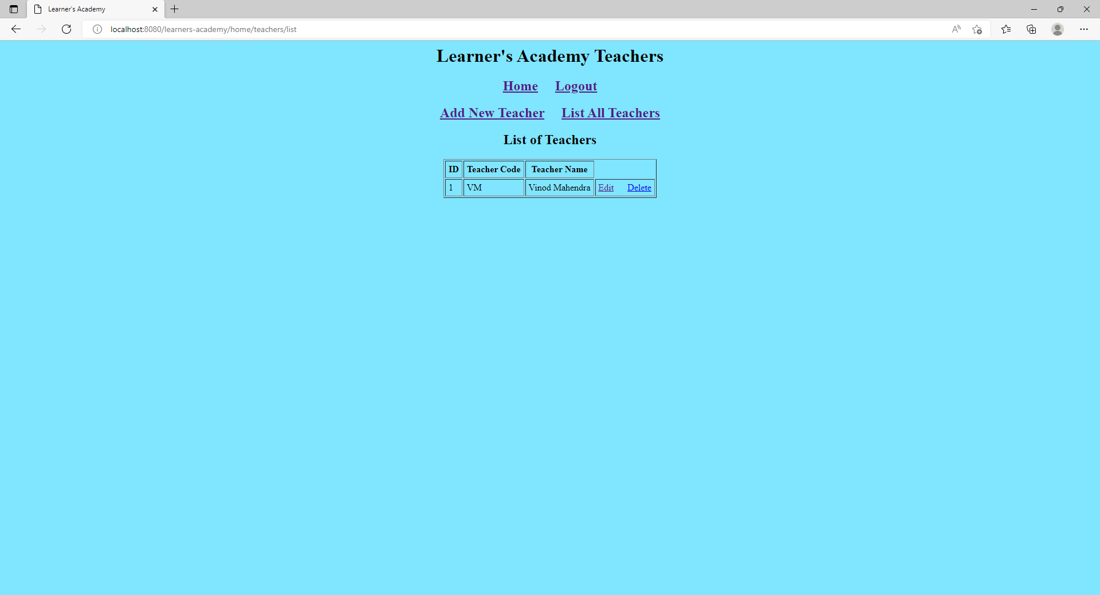

**Classes Maintenance Page**

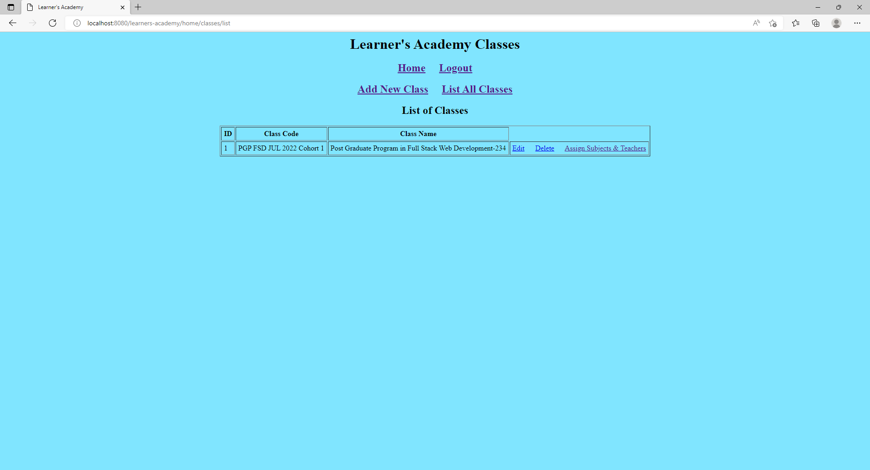

**Assign Subjects and Teachers to the Class Maintenance Page**

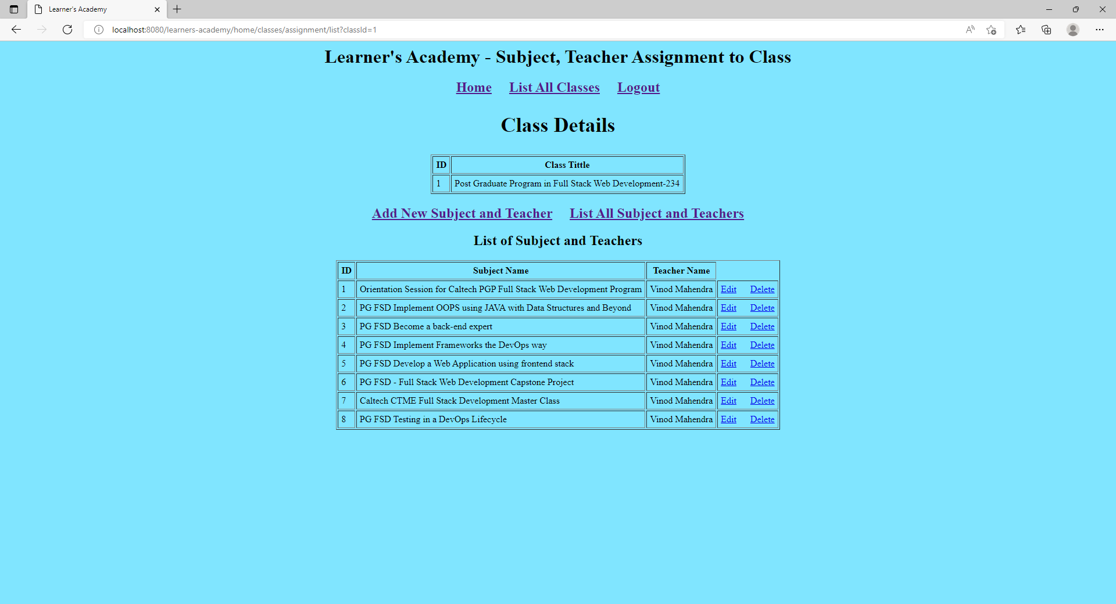

**Students Maintenance Page**

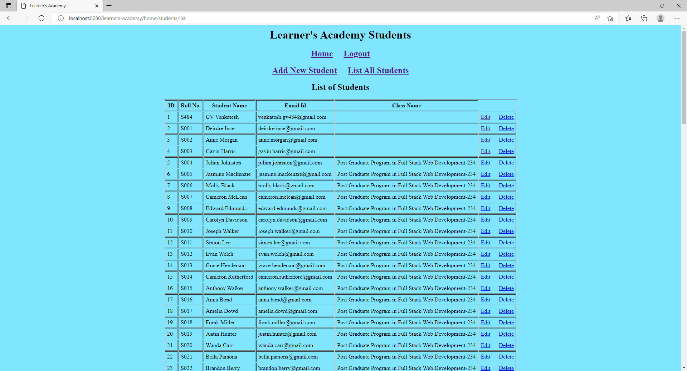

**Class Report**

